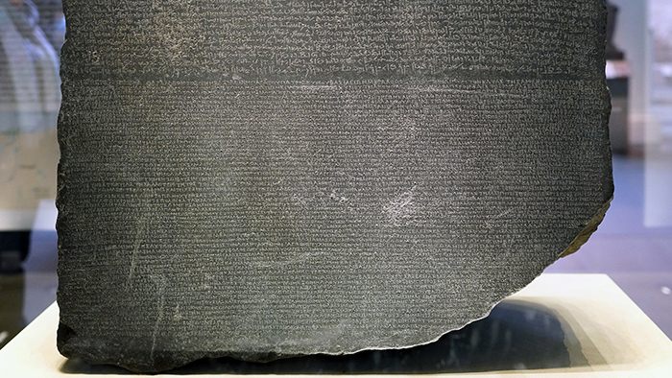

This artifact holds the key to understanding a language that was long not in use thousands of years ago. The Rosetta Stone is a stone with the Greek inscription to decipher hieroglyphics. With that we were able to study the history of ancient Egypt. Also, the artifact holds a strong value to politics and the society that reflected through it. The inscriptions are three translations of the same decree, passed by a council of priests, that affirms the royal cult of the thirteen-year-old Ptolemy V on the first anniversary of his coronation. The decree is inscribed on the stone three times, in hieroglyphic (suitable for a priestly decree), demotic (the native script used for daily purposes), and Greek (the language of the administration). The importance of this to Egyptology is immense. In the early years of the nineteenth century, scholars were able to use the Greek inscription on this stone as the key to deciphering the others.

**Resources**

The Rosetta Stone. (n.d.). https://www.khanacademy.org/humanities/ancient-art-civilizations/egypt-art/ptolemaic/a/the-rosetta-stone